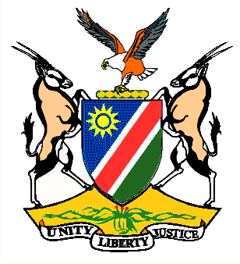

EMBASSY/PERMANENT MISSION OF THE REPUBLIC OF NAMIBIA

REPUBLIC OF NAMIBIA

Statement by Ms. Gladice Pickering – Legal Attaché, during the Interactive Dialogue on the Universal Periodic Review of Estonia, 19 January 2016, 14h30 – 18h00

Mr. President,
Namibia welcomes the delegation of Estonia to the 24th Session of the UPR and commends them on the presentation of their national report for this review.
We congratulate Estonia on the appointment of the Ombudsman for children and the establishment of the Gender Equality Council. We also take note of the adoption of the Welfare Development Plan for the period: 2016-2023.
We would like to know what measures were taken to implement the Action Plan to reduce the gender pay gap in Estonia?
Namibia would like to recommend:
1. Estonia to establish or designate a national human rights institution compliant with the Paris Principles.
2. Estonia to provide the Gender Equality Commissioner with sufficient resources to enable the institution to fulfill its mandate effectively and independently.
We wish Estonia all the best during their review.
I thank you Mr. President.

